**Wilson Sporting Goods**

*Developer Guide*

|  |  |  |
| --- | --- | --- |
| **Supervisor.** | **Miss Nashmia Khan** | |
| **Batch.** | **2305F1** | |
| **Group.** |  | |
| **Serial No.** | **Enrollment Number** | **Student Name** |
| 1. | 1465057 | MUHAMMAD AMIN BULAQI |
| 2. | 1465456 | MUHAMMAD  FAHAD SHEIKH |
| 3. | 1472864 | MUHAMMAD  NEHAL ALEEM |
| 4. | 1463403 | SAMEER MALIK |

1. **Home** (*index (1).html*)

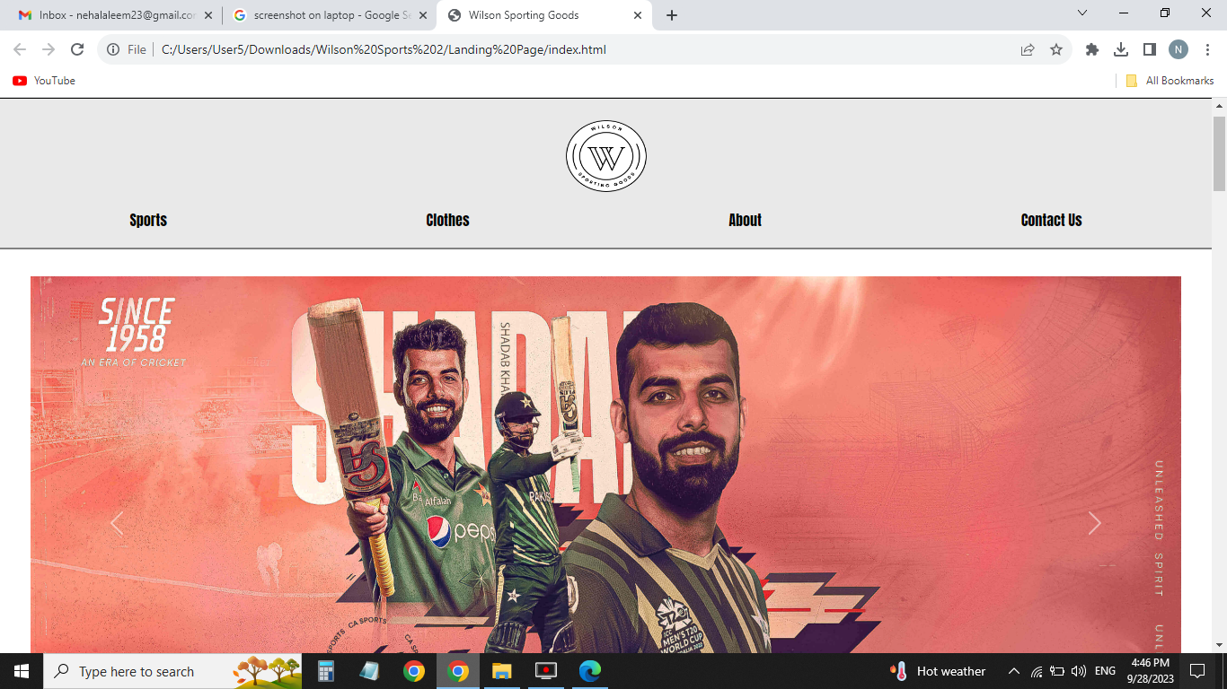

***Figure 1: Home page to Wilson Sporting Goods***

* By clicking (**logo**) button user will redirect to the main webpage.

**Code of Home page**

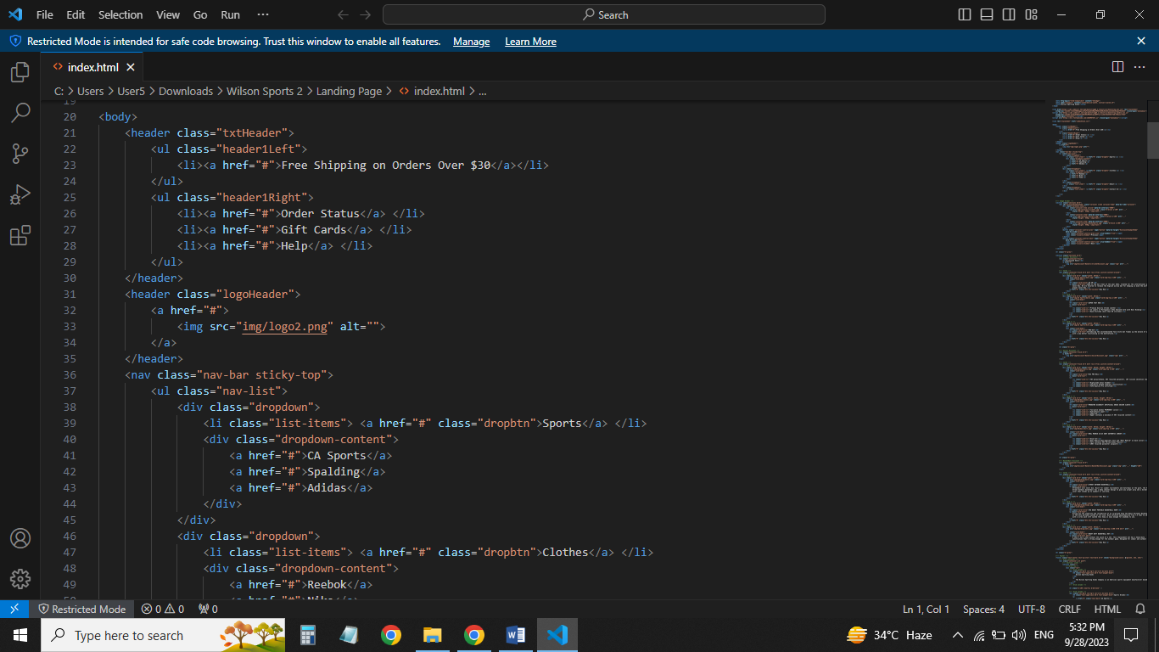

**Navbar (index.html)**

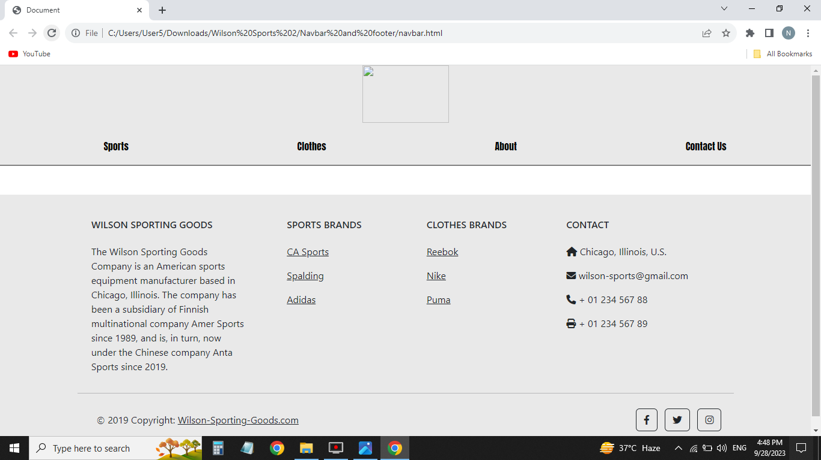

***Figure 2: Footer***

We have given seven essentials. By clicking any of the essential’s and redirect to the linked page. (index.html, CApage.html, Adidas.html, spalding.html, reebok.html, nike.html, puma.html, comparison.html, aboutus.html, contact.html )

**Code of Navbar**

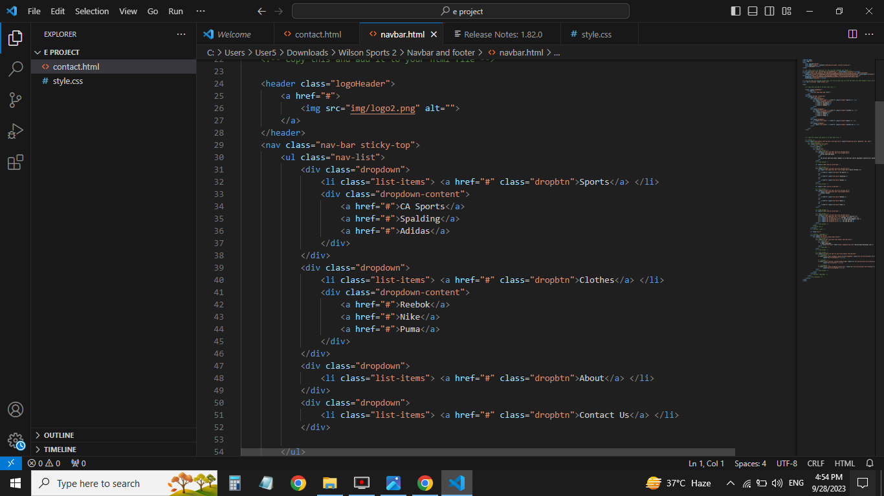

**About us (aboutus.html)**

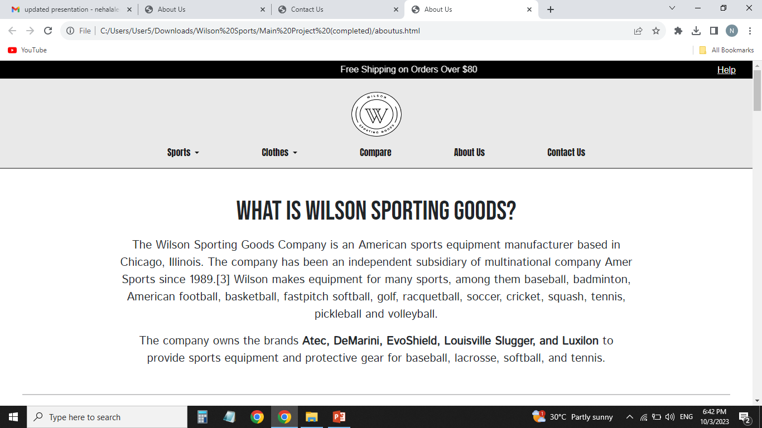

 ***Figure 3: About us***

**

***Code of About Us***

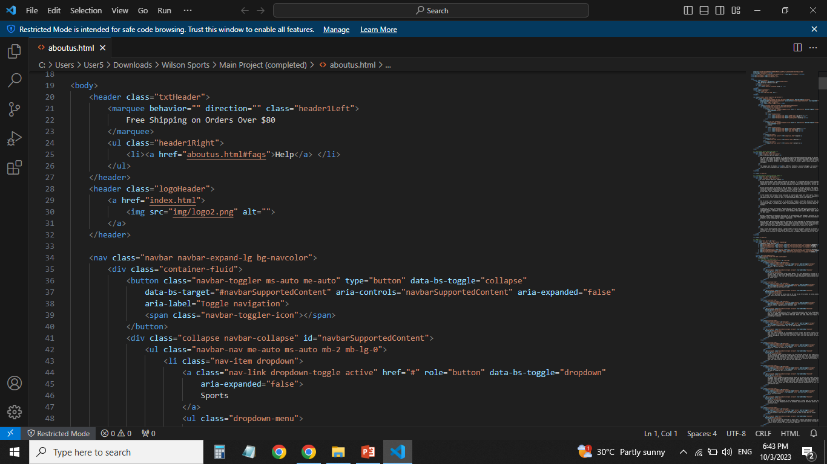

1. ***Our Team (index (1).html):***



***M. Amin Bulaqi Sameer Malik Nehal Aleem Fahad Sheikh***

***Contact (contact.html):***

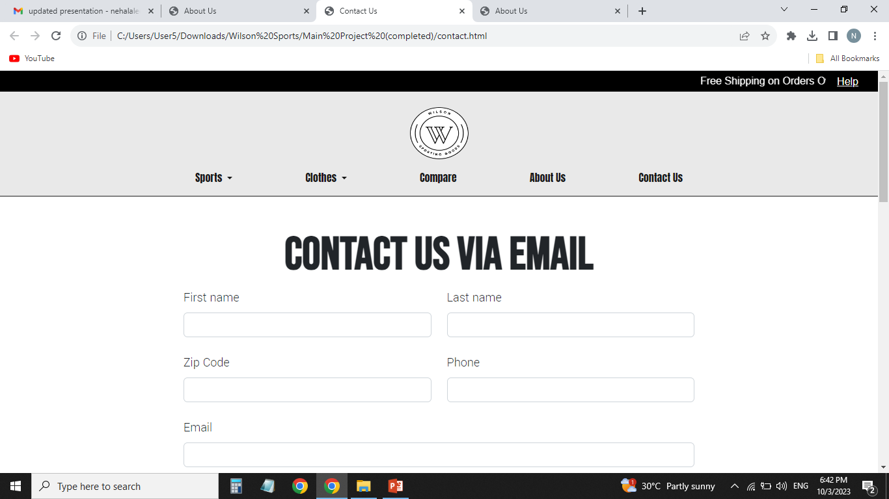

***Figure 13: Contact***

*In our contact section we have given location map for the ease of the people*

*Email id and phone number for contacting in case of any problem.*

*Feedback Form:*

*To know the response of the people our team has given feedback page for the ideas and feedback of the people.*

***Code of Contact***

